Assignment day 3

Creating tasks, issues, test cases, events

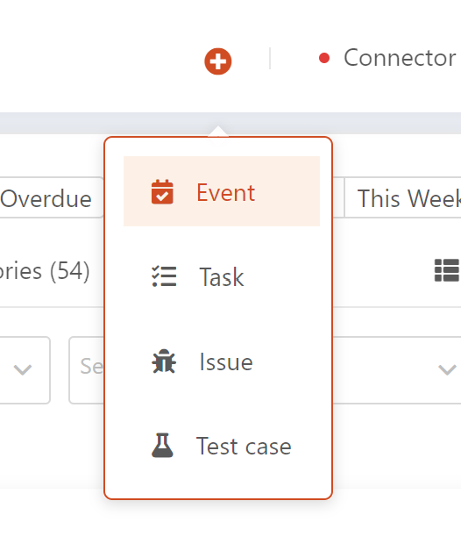

Event

For creating an event, we require the following fields,

* + - Event name
    - Event Agenda
    - Event Span
    - Start Time
    - Participants
    - Meeting Status
    - Parent Name
    - Event Link
    - Event Location

Note: Fields in Red are mandatory.

Page where the event can be created.

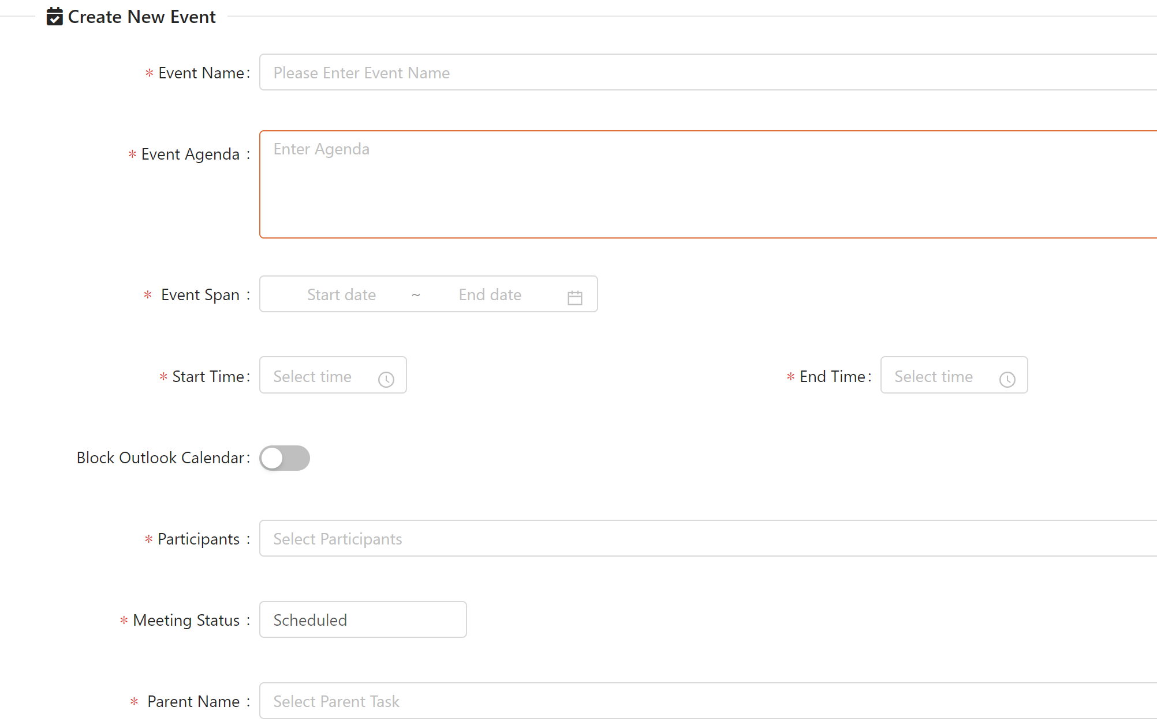

Task

Tasks requires the following fields for creation,

In overview tab,

We require, Task Title, status, task Type(config, custom, dev), Priority, parent Name.

In StaKeHolder Information,

We have Assigned to, Participants fields

In Planned and actual we have when the task is planned and when the task is actually completed.

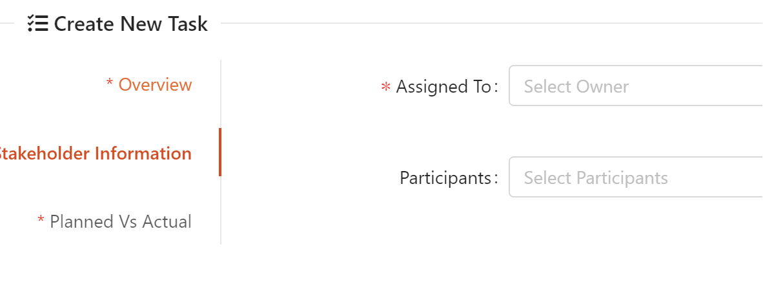

Issue – the details about the issue and how it needs to be addressed.

Status, source of the issue, testcase and priority are required fields

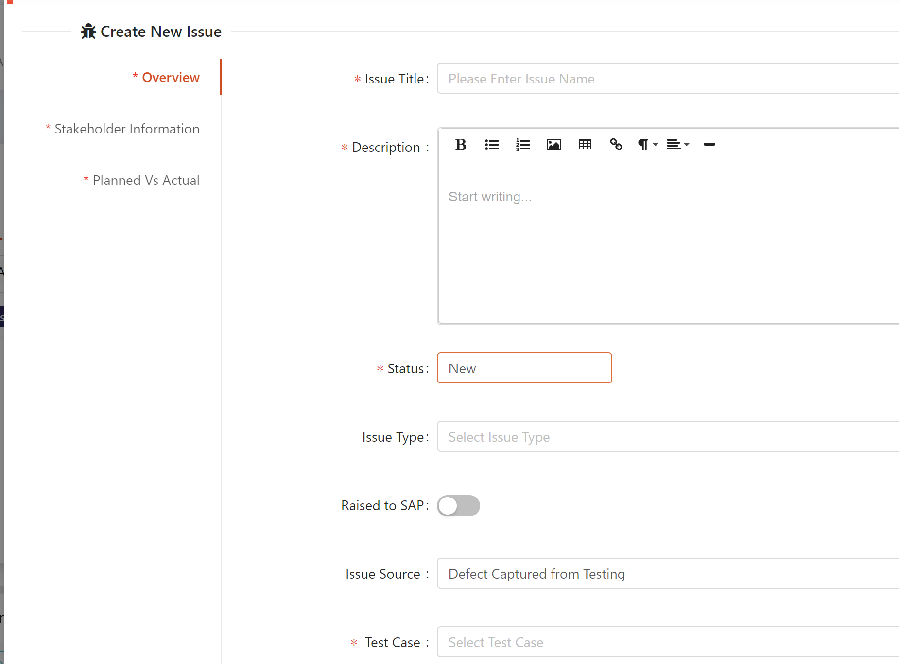

Test case – more similar like taking up the input and output and checking whether they are working properly, and the status of the test case.

